OCR A Level Computer Science (H446)

**Creating A Barber Application**

NEA Project

Table of Contents

Project Overview: 3

Stakeholder: 3

Computational Method: 4

Problem Recognition: 4

Problem decomposition: 4

Interview: 4

Interview Questions (Clients): 5

Interview Answers (Clients): 5

Analysis of Interview (Client): 6

Interview Questions (Saloon): 6

Interview Answers (Saloon): 6

Analysis of Interview (Saloon): 7

Research: 8

Existing Solutions: 8

Essential Features: 9

Limitations: 9

Requirements: 10

Software Requirements: 10

Hardware Requirements: 10

Success Criteria: 10

**Analysis**

# Project Overview:

During this pandemic, many salon and barber shops had to only allow few people to enter inside at a time which caused large queue and frustration for the clients which also meant salon business to lose on clients, therefore I thought of an online queuing idea where they can book an appointment on their phone and it will put them into a queuing system and provide with necessary information such as timing, cost and their position. This will allow them to stay at home and come into the shop when they need to so they can save time and it will make the shops run more efficient and safer rather than queuing outside the stop for a long time and being close to other clients.

This will also help the shop as they could still be able to open and follow the rules. The shop will gain more clients as it will be more organised and seem more professional.

As a result of this, I am planning to make an application which will be suited for the saloon/barber shop and it will ensure the public can create an account and book an appointment with their desired hairdresser and place them into a queue which they can see live.

# Stakeholder:

The consumers of this application will be the clients of the saloon/barber shop. It would have a great graphical user interface which will be easy for the clients to book an appointment and it will show the necessary information very clear. I have asked few of my colleagues for their opinion and feedback for this app and they have said:

* Options of different haircuts
* Showing hairdresser names
* Prices of haircut
* Queueing time

It will be beneficial for the owner of the salon as they can see how many customers they are going to serve; therefore, the owners can assign the right amount of hairdresser and can close their shop earlier as they would know the time of the last customers.

In conclusion, I would use these feedbacks to make my application which will be ideal and suitable for the clients to use. The system will be easy to book appointment with three clicks so it will be less hassle for the clients. This application would be able to work with any saloon/barber shop and wouldn’t need any administration or any other expenses to run the service. My application will be really ideal for clients as many people hate queuing for a long time, just to get a haircut.

# Computational Method:

This program will need to have computational method to execute many of the instructions. It would need to abstract information such as the clients’ names in the queue so it won’t go against the Data Protection Act 2018 and may affect the clients’ privacy. It also needs to calculate the estimation time for the client until they can access the saloon.

1

2

3

4

4

IN

OUT

Queue List

1

This illustration presents a Queue data structure which will allocate each client with a position and it will run on a first in, first out data structure.

When the client had booked a position, the program has to give a temporary position number and place them into the queue, and it will have to background refresh and decrease the position number as the first client has finished.

## Problem Recognition:

A problem the clients could have is forgetting the password for the login, as a result of this I am going to add a reset password link where they can change their password and log back in. The overall problem is placing each client into the queue list, as I would have to give each client with a position number which is not been used up already and place them into the list and provide a live list where the position number decreases as one client is done.

## Problem decomposition:

This problem can be decomposed in to set of smaller steps. Here’s an initial idea of the steps I am going to carry out:

* When the client books an appointment, I have to check the next available position number and provide them with a number.
* Show their name in the live list.
* As soon as one client is done, their number should decrease.
* Have background refresh so the client would be alerted with their position.

# Interview:

I am going to ask few questions to possible stakeholders of the app and salon shops to discover their feedbacks and use them to develop my applications. I may ask them with a follow up question or tell them to elaborate their answers.

## Interview Questions (Clients):

1. How would you normally book an appointment for your local saloon?
2. Are you satisfied with the way you can get a haircut?
3. How long does it take from the time of waiting in the queue to having a haircut?
4. If there was an app where you can book an appointment and go to the salon at a specific time, would you benefit from this?
5. If this software appeals to you, how would you like it to be designed as?
6. Would you like any features which can help you or make it more appealing to you?
7. Do you have any feedback?

* Question 1,2 and 3 will establish them to show their history of booking an appointment to me and this will allow them to reflect on how it wasn’t an ideal or time-saving way, and it will allow myself to provide them another solution (my application) to themself.
* Question 4 and 5 will give them an idea of how it could be much easier and make them get involved and see if this application would help them or not.
* Question 6 and 7 makes them to provide any feedback they could want in the app or to remove so it can be easier for them and this will help me in the designing process.

## Interview Answers (Clients):

Michael

1. **How would you normally book an appointment for your local saloon?**

“Normally I go to my local salon and wait until there is a free space for me.”

1. **Are you satisfied with the way you can get a haircut?**

“Not really, as most time there will be a long queue outside the salon, and it is time consuming for me as I could have spent that time on something useful.”

1. **How long does it take from the time of waiting in the queue to having a haircut?**

“It depends on the time and day, usually it takes me up to 3 hours to take a haircut and reach home. For the three hours I will be in the salon spending third of the time waiting for an empty space.”

1. **If there was an app where you can book an appointment and go to the salon at specific time, would you benefit from this?**

“Yes, this potential app would help as it could allow to save time by booking in advance and not spend couple of hours for waiting for free space. It could also help me to see if my hairdresser is available.”

1. **If this software appeals to you, how would you like it to be designed as?**

“I would like to have an own account where I can link with my local salon and make an appointment with easy clicks. It should also allow me to pick specific haircut, so I won’t need to tell my hairdresser what I want.”

1. **Would you like any features which can help you or make it more appealing to you?** “Personally, I would love a contact feature where I can contact the salon to find more information or any enquires, I could have.”
2. **Do you have any feedback?**

“Not really, I hope I can use this app in the future, and it can make getting a haircut

more efficient and less time needed.

## Analysis of Interview (Client):

From the interview, I can learn that the clients take a lot of time to get a haircut as I

predicted and they would be interested in this app as it would help them to save time

however, the stakeholders that were interviewed, haven’t used an app before to book an

appointment therefore they would want it to be simple and easy to use. I would take these

feedbacks to make couple changes to my application and make it ideal for the stakeholder.

## Interview Questions (Saloon):

1. How do you normally accept clients to get a haircut?
2. Do you have any appropriate queuing system?
3. How much salary has been wasted due to waiting for clients and overcrowding staff?
4. If there was an app where the clients can book an appointment and go to the salon at a specific time, would you benefit from this?
5. If this software appeals to you, how would you like it to be designed as?
6. Would you like any features which can help you or make it more appealing to you?
7. Do you have any feedback?

* Question 1,2 and 3 will establish them to show their history of accepting clients to me and this will make them acknowledge on how it wasn’t an ideal or efficient way as it will allow them to save money for staff salary, and it will allow myself to provide them another solution (my application) to themself.
* Question 4 and 5 will give them an idea of how it could be much easier for the clients and makes them get involved and see if this application would help them or not.
* Question 6 and 7 makes them to provide any feedback they could want in the app or to remove so it can be easier for them and this will help me in the designing process.

## Interview Answers (Saloon):

Barber Tom

1. **How do you normally accept clients to get a haircut?**

“We accept clients whoever comes to the salon and normally during weekends we have a lot of clients crowding up.”

1. **Do you have any appropriate queuing system?**

“Nope we don’t have any queuing system, only the basic first come first serve basis.”

1. **How much salary has been wasted due to waiting for clients and overcrowding staff?**

“We have many hairdressers always available for work and during the weekday we don’t have many clients, so we have couple of hairdressers who are getting paid but don’t have clients to attend, and this has been a problem as they are getting paid for doing nothing. However, we can’t choose amount of hairdresser we need in the salon as we don’t know how many clients we are going to get per day.”

1. **If there was an app where the clients can book an appointment and go to the salon at a specific time, would you benefit from this?**

“Yes, we would benefit this as I would give us an idea of how many clients are coming

which we can use the choose the amount of hairdresser needed. It will also tell us

the times of the client coming so we can get the salon ready. This will make us save

money and time.”

1. **If this software appeals to you, how would you like it to be designed as?**

**“**I would like it to display a table of clients who are coming so we know who is next

and number of clients we have left. It should also be easy to use and should be simple

for the hairdresser to understand. It should be technical to use”

1. **Would you like any features which can help you or make it more appealing to you?**

“Nope, the program you have showed and discussed seems really good and satisfies

what I look for in an app.”

1. **Do you have any feedback?**

“Nope”

## Analysis of Interview (Saloon):

From this interview, what I can take in is that the salon has overcrowding and extra staffing

problems, therefore they are interested in my application as it will be solution to their

problem. Using the answers, I can interpret that they would also want an easy and simple

user interface to use so they can see their clients and other information and they would

want to be user-friendly as most of the hairdressers aren’t experienced in technology, so

I would use this feedback and make my application simple for everyone to understand and

use.

# Research:

I am going to research to see if there are any other similar application to mine and compare them.

## Existing Solutions:

**Appointfix**

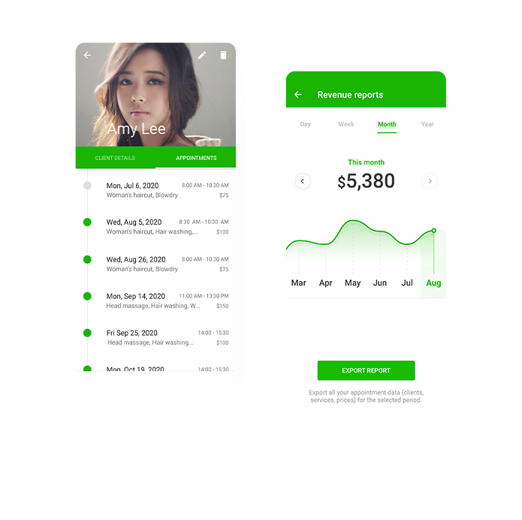Appointfix is a free appointment scheduling app that makes life easier for beauty, fitness, and wellness professionals. The app helps you effortlessly schedule appointments and reduce no-shows using automated text reminders.

Comparing to my application, this is used for general scheduling so it won’t be fully programmed for barber clients which means the clients won’t get the full potential experience as they would using my application because it was just made for barber clients. However, I can take some ideas such as reducing no shows by using automated text reminders to alert the clients of their appointment.

**Fresha**

Fresha allows salon to join their app and display their salon so they can gain more clients. It allows their salon to be promoted with their app which will increase their popularity.

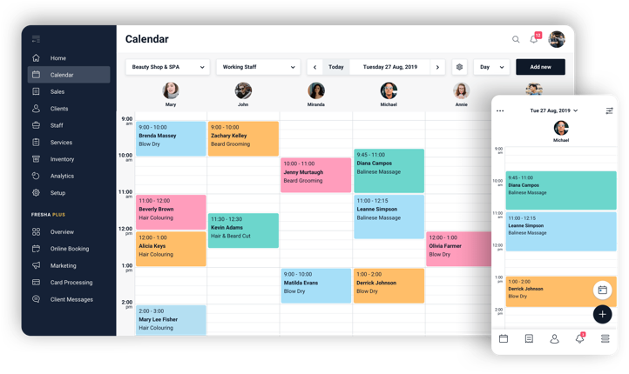 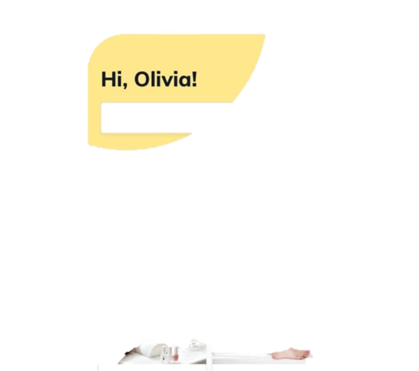

Comparing to my application, I can gain the ideas of taking payments from the clients straight away so it would be easier for the salon to track payments and during the pandemic online transaction has been in used more recently. This will help my application to more efficient, and help the salon to ensure that the clients will come in.

# Essential Features:

In order for the program to be available for the stakeholders, I have to publish the application to Google Play Store, this will allow the stakeholders to download the application and use it. Also, I have to speak to many salons and discuss to them about the application and make them to join the application, so the clients have many varieties to book an appointment from.

The application should let the salon to enter which hairdressers are available and let them to have limited control of their side so they can choose if they want to be online or offline in the app.

My main intention is that client should be able to book an appointment as simple and efficient as it can be, so I would introduce a join-queue section where they would book an appointment to a next available space to their desired salon and join the queue as soon as possible, this will be really simple for the clients as they won’t need to spend time on choosing time and date for their appointment so I would need a computational method for the program to choose the next available space for them.

# Limitations:

One main limitation would be not processing any payments as it is difficult for me to have a payment method for the clients to pay ahead of their appointment, this will limit me from ensuring the salon the clients will be attending as there is no way of charging the clients.

Another limitation could be not having test on actual saloon as they are all closed due to the pandemic, so this will limit me from fixing any future problems that the client or salon may have when using the application.

Another limitation is that the application won’t be available to non-Android user as it is coded in Android Studio so it will only support Android phones. So, this will cut many potential clients from using the application.

Also, Firebase only allows certain number accounts to be made so this will also limit my application from being used by many clients.

This project will be limited by the amount of time I have as I will be making this application along with my A-Levels therefore I won’t be able to spend many hours and try to make the application really perfect and have all the features I planned to have in my program.

# Requirements:

## Software Requirements:

* **Android Operating System** – Minimum Android 4.1 API support level 16
* **Google Play Service** – Minimum version of 4.3.4
* **Resolution** – Optimum resolution 1080 x 2160
* **Minimum Storage Size** – 10MB & RAM size of 500MB

## Hardware Requirements:

* **Android Supported Device** – Need a device where Android is the operating system as the application is coded in java and used android functions so only Android device can translate and compile the program.
* **Android Television** – Need a television for the salon to display the queue of the clients so it will be visible to all the hairdressers in the salon.

The user will need an Android Device and Google Play service to download the application and run the application. They would need know have the requirements suggested above to be able to use the application.

An Android Television would be ideal for the salon to use as it will have massive screen to display the queue to see how many clients left and who is next for a haircut. It will display a table of clients’ name and contact number incase they would want to connect with them and it will also let the salon to accept any more offers.

# Success Criteria:

* **The program should be able to let the user to make account and login.**

They should be able to make an account with their name and valid email address and use a suitable password.

* **The program should be able to let the user to book appointment.**

This is the main purpose of the program. It should ask the user for the date and time and which hairdresser they would like to book the appointment with.

* **The program should be able the user to join the queue with one click.**

This is the join-queue section where they can click the one click and automatically join the queue in the next available space.

* **The program should let the user to check the queue.**

They should be able to access the queue list and see what position they are.

* **The program should let the salon to be offline or online whenever.**

The salon user should be able to be online when they want to get clients and stop getting client whenever they want to.

* **The program should let the salon to enter number of hairdressers and name to display in the program to show the clients.**

This should be done so the clients can choose which hairdressers they would want to book an appointment with.